Streaming Data from Kafka to Your XGBoost Fraud Detection Model 🚀
To stream transaction data from Apache Kafka to your XGBoost model in real time, follow these steps:

📌 Overview of the Architecture
- Kafka Producer: Streams transaction data to a Kafka topic.
- Kafka Consumer (Flask App or Python Script): Reads data from Kafka and passes it to the trained XGBoost model.
- XGBoost Model: Predicts fraud or non-fraud based on incoming transactions.
- Fraud Response Handling: Send results to another Kafka topic, a database, or trigger alerts.

1️)Set Up Kafka Producer (Streaming Transactions)
This producer will simulate transaction data and send it to Kafka.
Kafka Producer (kafka_producer.py)
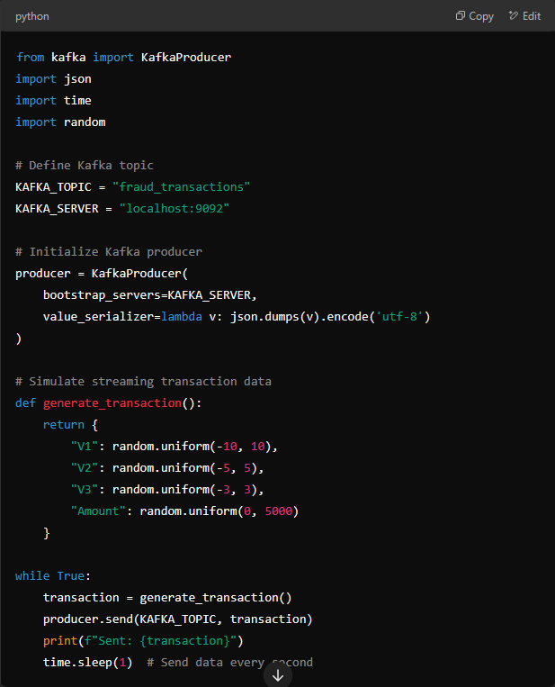
from kafka import KafkaProducer
import json
import time
import random

# Define Kafka topic
KAFKA_TOPIC = "fraud_transactions"
KAFKA_SERVER = "localhost:9092"

# Initialize Kafka producer
producer = KafkaProducer(
bootstrap_servers=KAFKA_SERVER,
value_serializer=lambda v: json.dumps(v).encode('utf-8')
)

# Simulate streaming transaction data
def generate_transaction():
return {
"V1": random.uniform(-10, 10),
"V2": random.uniform(-5, 5),
"V3": random.uniform(-3, 3),
"Amount": random.uniform(0, 5000)
}

while True:
transaction = generate_transaction()
producer.send(KAFKA_TOPIC, transaction)
print(f"Sent: {transaction}")
time.sleep(1) # Send data every second

✅ This script continuously sends simulated transactions to Kafka.

2️)Set Up Kafka Consumer & Connect It to XGBoost Model
The consumer will read data from Kafka and pass it to your fraud detection model.
Kafka Consumer & Model Prediction (kafka_consumer.py)
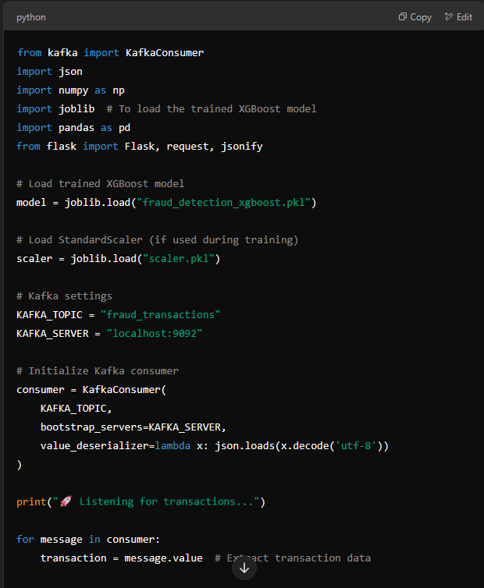
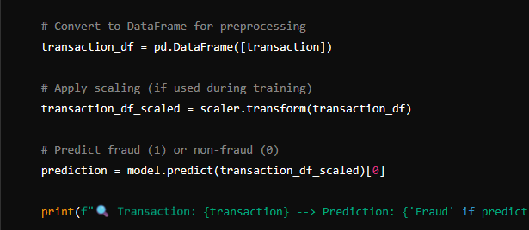
from kafka import KafkaConsumer
import json
import numpy as np
import joblib # To load the trained XGBoost model
import pandas as pd
from flask import Flask, request, jsonify

# Load trained XGBoost model
model = joblib.load("fraud_detection_xgboost.pkl")

# Load StandardScaler (if used during training)
scaler = joblib.load("scaler.pkl")

# Kafka settings
KAFKA_TOPIC = "fraud_transactions"
KAFKA_SERVER = "localhost:9092"

# Initialize Kafka consumer
consumer = KafkaConsumer(
KAFKA_TOPIC,
bootstrap_servers=KAFKA_SERVER,
value_deserializer=lambda x: json.loads(x.decode('utf-8'))
)

print("🚀 Listening for transactions...")

for message in consumer:
transaction = message.value # Extract transaction data

# Convert to DataFrame for preprocessing
transaction_df = pd.DataFrame([transaction])

# Apply scaling (if used during training)
transaction_df_scaled = scaler.transform(transaction_df)

# Predict fraud (1) or non-fraud (0)
prediction = model.predict(transaction_df_scaled)[0]

print(f"🔍 Transaction: {transaction} --> Prediction: {'Fraud' if prediction == 1 else 'Legit'}")

✅ This script listens for new transactions from Kafka and runs fraud detection using XGBoost.

3️)Running Everything
Step 1: Start Kafka
If not already running, start Kafka & Zookeeper:
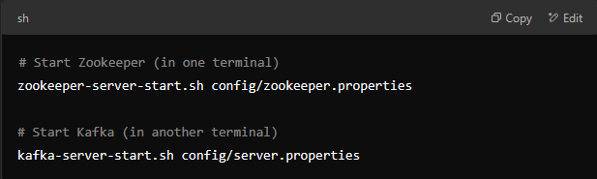
Step 2: Start the Producer
Run:
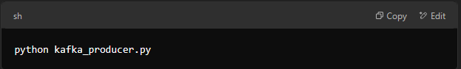
This will start sending transactions to Kafka.
Step 3: Start the Consumer & Fraud Detection
Run:
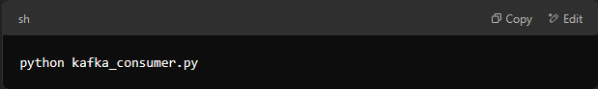
This will start listening for transactions and detecting fraud in real-time.

🔹 4️⃣ Next Steps:
- Integrate with Java (Spring Boot)
  - Send the fraud detection results to a Kafka topic or a database for the Java service to consume.
- Optimize Performance
  - Use Kafka Streams for parallel processing.
  - Deploy the consumer using Docker or Kubernetes for scalability.
- Deploy to Production
  - Deploy your Kafka cluster on AWS MSK, Confluent Cloud, or Apache Kafka on Kubernetes (Strimzi).

📌 Role of Apache Kafka in Your Fraud Detection Project
Apache Kafka acts as a real-time data streaming platform in your fraud detection system. It enables efficient, scalable, and fault-tolerant streaming of transaction data between various components.

🔹 1️) Kafka as a Message Broker
Kafka connects different components of your fraud detection system. It allows producers (transaction sources) to stream data and consumers (your ML model) to process it in real-time.

🔹 2️) Real-Time Transaction Streaming
Kafka streams transaction data to your fraud detection model. Instead of using static datasets, Kafka enables: ✅ Continuous transaction monitoring
✅ Low-latency processing
✅ Fraud detection in real-time

🔹 3️) Kafka Producer: Streaming Transactions
Kafka producers send transaction data to a Kafka topic (e.g., "fraud_transactions").
✔ Example source: A payment gateway, banking system, or simulated transactions.
📝 Producer Example (Simulating Transactions)
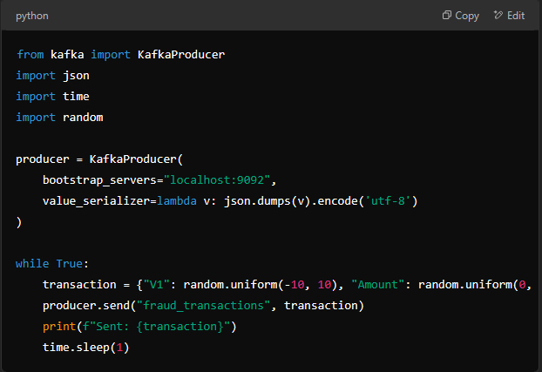
from kafka import KafkaProducer
import json
import time
import random

producer = KafkaProducer(
bootstrap_servers="localhost:9092",
value_serializer=lambda v: json.dumps(v).encode('utf-8')
)

while True:
transaction = {"V1": random.uniform(-10, 10), "Amount": random.uniform(0, 5000)}
producer.send("fraud_transactions", transaction)
print(f"Sent: {transaction}")
time.sleep(1)
🔹 Kafka Producer continuously sends transactions to Kafka.

🔹 4️) Kafka Consumer: Fraud Detection Model
Kafka consumers subscribe to the "fraud_transactions" topic, receive transaction data, and send it to the ML model for fraud prediction.
📝 Consumer Example (Feeding Kafka Data into XGBoost Model)
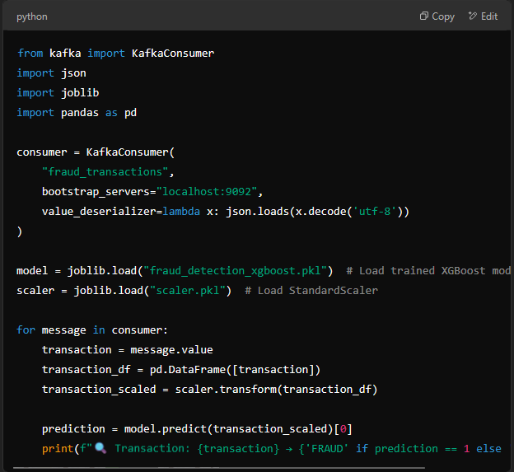
from kafka import KafkaConsumer
import json
import joblib
import pandas as pd

consumer = KafkaConsumer(
"fraud_transactions",
bootstrap_servers="localhost:9092",
value_deserializer=lambda x: json.loads(x.decode('utf-8'))
)

model = joblib.load("fraud_detection_xgboost.pkl") # Load trained XGBoost model
scaler = joblib.load("scaler.pkl") # Load StandardScaler

for message in consumer:
transaction = message.value
transaction_df = pd.DataFrame([transaction])
transaction_scaled = scaler.transform(transaction_df)

prediction = model.predict(transaction_scaled)[0]
print(f"🔍 Transaction: {transaction} → {'FRAUD' if prediction == 1 else 'LEGIT'}")

🔹 The model predicts fraud in real-time for each Kafka event.

🔹 5️) Kafka Enables Java Integration
Kafka allows your Java-based fraud detection system to: ✅ Receive predictions from the Python ML model
✅ Store transaction data in a database
✅ Trigger fraud alerts

📌 Summary: Kafka’s Role in Fraud Detection
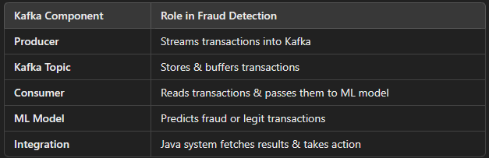
🚀 Final Thought
Kafka bridges the gap between live transactions and fraud detection in real-time. Without Kafka, the model would rely only on batch processing instead of continuous fraud monitoring.

🛠️ Installing Apache Kafka (Windows & Linux)
Kafka requires Java (JDK 8 or later) and Zookeeper to function. Follow the steps below based on your operating system.

🔹 1️) Install Java (Required)
Before installing Kafka, ensure you have Java 8 or later installed.
🔹 Check Java version
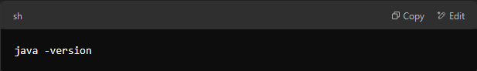
✅ If Java is not installed, download and install JDK and set up the JAVA_HOME environment variable.

🔹 2️⃣ Download Apache Kafka
Download the latest Kafka binary from the official website:
🔗 Kafka Download Page
📌 For Kafka 3.7.0 (Latest Stable Version), run:
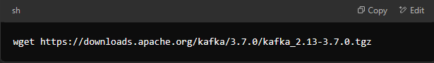
Once downloaded, extract it:
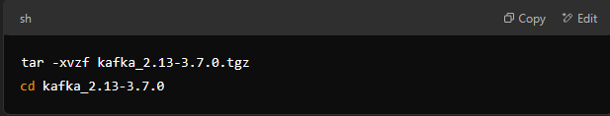

3️) Start Zookeeper (Kafka Dependency)
Kafka uses Zookeeper to manage brokers and metadata.
📌 Start Zookeeper:
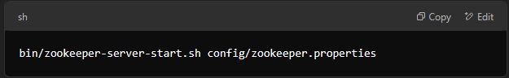
(For Windows, use bin\windows\kafka-server-start.bat config\server.properties)

🔹 5️) Create a Kafka Topic
Kafka topics store messages. You need to create a topic for fraud detection transactions.
📌 Create a topic named "fraud_transactions":
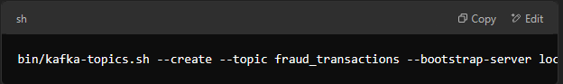
bin/kafka-topics.sh --create --topic fraud_transactions --bootstrap-server localhost:9092 --partitions 1 --replication-factor 1
(For Windows, use bin\windows\kafka-topics.bat instead of .sh)
📌 Verify topic creation:
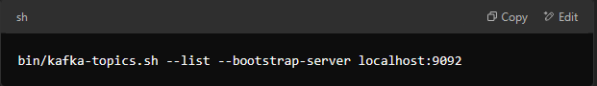

🔹 6️) Test Kafka Producer & Consumer
📌 Start Producer to send messages:
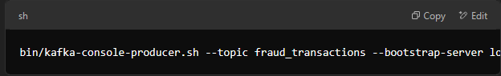
bin/kafka-console-producer.sh --topic fraud_transactions --bootstrap-server localhost:9092
(For Windows, use bin\windows\kafka-console-producer.bat)
Type some messages and press Enter.
📌 Start Consumer to receive messages:
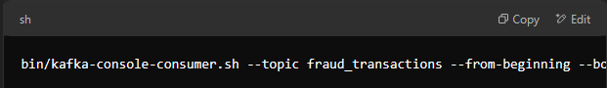
bin/kafka-console-consumer.sh --topic fraud_transactions --from-beginning --bootstrap-server localhost:9092
(For Windows, use bin\windows\kafka-console-consumer.bat)
If everything works fine, your messages should be displayed in the consumer terminal.

🔹 7️) Configure Kafka for External Connections (Optional)
By default, Kafka runs on localhost. If you need external access, update the server.properties file:
📌 Edit config/server.properties:
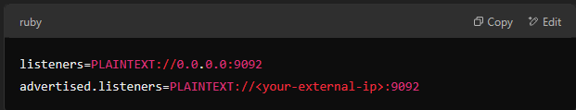
Restart Kafka after making these changes.

✅ Kafka Installation Summary
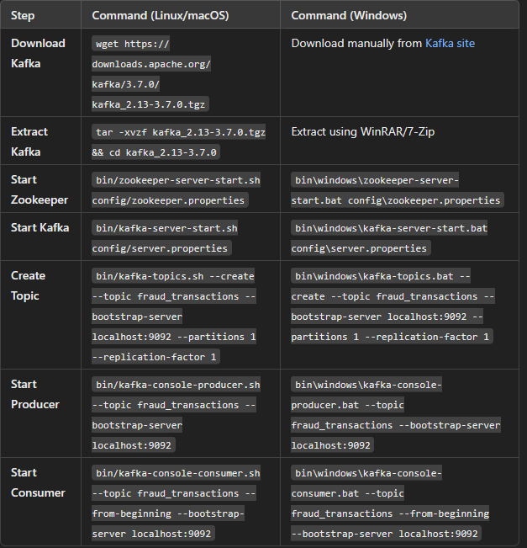

🚀 Next Steps
1️) Integrate Kafka Producer in Java (Spring Boot) or Python
2️) Stream transactions from Kafka into your XGBoost Fraud Detection Model
3️) Use Kafka Consumer to process real-time predictions

